Kennesaw State University (KSU)
College of Computing and Software Engineering (CCSE)
CS-3503 Computer Organization & Architecture
STUDENT NAME: .
Lab-1: MARIE Simulation & Analysis
using MARIE Assembly Language Programming
Total Points: 10
Submission: Please fill out all your answers or results following the directions and the space provided for each question below. Then, using this file, complete the quiz named “Lab1 MARIE”; this will enable us grade and create reports efficiently.
Lab Directions: This lab exercise asks you to individually simulate and analyze MARIE (a hypothetical computer architecture to understand basic computer operation) based Assembly Language Program (given next and to the left) manually, and later on, by using MARIE Simulator (launch it by executing “MarieSim.jar” file) and MARIE Data Path Simulator (launch it by executing “MarieDP1.jar” file) both of which are provided on D2L as a ZIP file that includes four example MARIE assembly program files, and two user guides as well.
Address (Hex) | Machine Code (Hex)
200
201
202
203
204
205
206
207
208
209
20A
20B
20C

Figure-1: MARIE Assembly Program for Lab1
Table-1: Machine Program for Lab1

- (2-points) Solve manually. Find the hexadecimal machine code (it will be a 16-bit word and hence four hexadecimal digits e.g. AB2D) manually for each instruction of the MARIE assembly program above that would be present in the IR when that instruction is being executed. All these instructions are combined sequentially for the whole program and will be written to the Program Memory of the computer. Please enter next to the Address (in hexadecimal) the machine code (in hexadecimal) in the Table-1 provided above .

- (2-points) Solve manually. By analyzing or tracing the code above manually, fill in the following blank with the hexadecimal value stored in the MARIE accumulator (AC) register when the program terminates.

_______________________

- (2-points) Implement the above MARIE program using MARIE Assembler Code Editor and run it in the MARIE Simulator (related resources are posted on the D2L) until it terminates. The image below shows the completion of the “Ex4_1” program from D2L zip file for your reference where the execution is terminated at the “HALT” instruction.

Now, insert the screenshot of your simulation of the Lab1 MARIE Assembly Program given above at its termination or halting of execution where all registers’ Hex values as well as the memory area of interest are clearly visible as shown in the sample figure below.

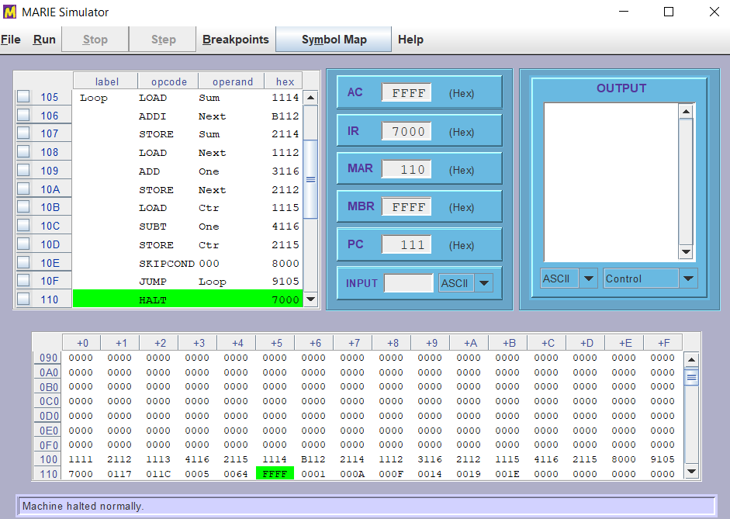

Hint: please note and match the line numbers as they are in the code given on top of this file. This can be done using the “ORG” instruction.

- (2-points) Each instruction of a program is executed through a Fetch-Decode-Execution (FDE) Cycle of a computer. MARIE Data Path Simulator (shown in the next figure) with Lab1 Program given above will help you analyze and understand this process. You will be executing only the first instruction which is “Load Base”; the Base Label points to the Hex address 209 where Hex 200 data is stored. The complete execution of only this Load instruction will eventually load the 0200h into the AC after the FDE Cycle for this instruction is completed.

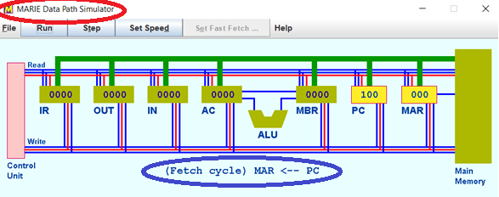

Insert below four images where each is a screenshot of the MARIE Datapath Simulator that includes an automatically generated and included tag (see the blue ellipse in the figure above) showing what step is going on at a point in time:
first image is before the FDE cycle for “Load Base” instruction’s execution begins, second image is when the Fetch step is completed, third image is when the Decode step is completed, and the fourth image is when the Execution step is completed, and hence, this will mark the completion of the FDE Cycle for the execution of the “Load Base” instruction.

Screenshot of before the FDE Cycle

Screenshot of after the Fetch step completion

Screenshot of after the Decode step completion

Screenshot of after the Execution step completion

- (2-points) Write and execute an assembly program using MARIE that outputs your first and last names. Your complete first name should be on the first line (row) and your complete last name should be on the second line (row) of the OUTPUT pane in the MARIE Simulator. Now, insert below the screenshot showing the termination of your program with the output full name displayed.
Hint: make sure you have “ASCII linefeed control and printing” option selected as “No Linefeed” in the Output pane of the MARIE Simulator.

